INTEGRITY
The foundation virtue in leadership
by
Roger Smalling, D.Min
This article corresponds to the book
Christian Leadership
available in Kindle.
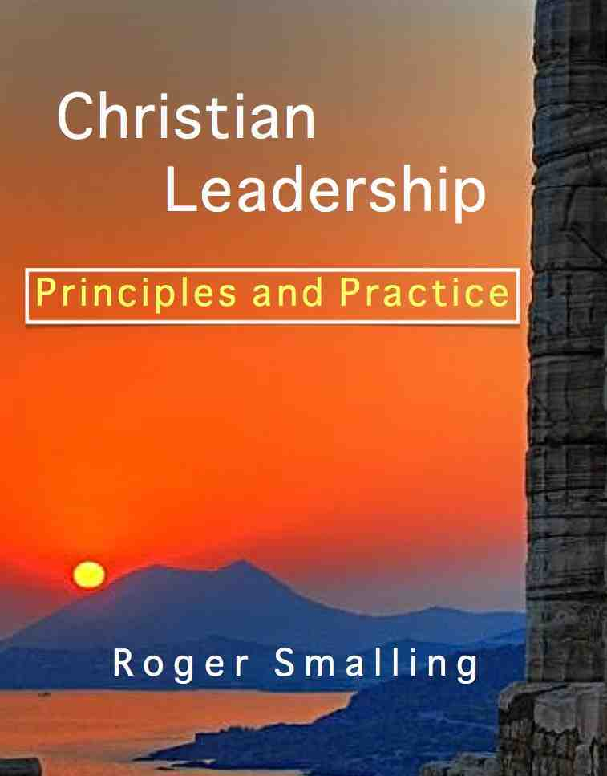

West Point, the United States Military Academy, is known for its strict code of honor. In response to any question, cadets may give only four answers: “Yes sir, No sir, I don't know sir, or No excuse sir.” Making excuses is a crime. If a person under a cadet's responsibility makes a mistake, the cadet takes the blame. This is to teach them responsibility, honor and most importantly, integrity.
One of their cadets graduated and was sent to Vietnam as a lieutenant. His first assignment was to supervise the construction of a runway that was already underway in the jungle. A sergeant was in charge. Unfortunately, the lieutenant knew nothing about runways. He asked the sergeant, “Are you sure the direction of this runway is correct?” The sergeant assured him it was. So the lieutenant said, “Well, continue on therefore and I'll trust your judgment.”
An hour and a half later, a colonel came by who was an expert in runways. He blared, “Who is the idiot who ordered the runway to be built in this direction?” The lieutenant almost replied, “This sergeant here said he knew...etc.” But his actual words were, “I did, sir.”
The colonel got up to the lieutenant's face and demanded, “Why did you order that?” The lieutenant replied, “No excuse, sir.”
At this moment, the sergeant approached, with his hand upraised as though wanting to explain. The colonel apparently deduced what had happened and asked the lieutenant, “You just graduated from West Point, didn't you?” The lieutenant said, “Yes sir.” The colonel glanced at the sergeant, then back at the lieutenant and concluded, “Well in that case, it was an honest mistake.”
Later on the colonel invited that lieutenant to join his staff. This represented a substantial promotion. Why did the colonel do that? He knew that men of integrity are both rare and valuable.
This true story illustrates the central virtue in leadership: Integrity. In the audio presentation on West Point Leadership Training in which this event was mentioned, the lecturer stated that if they can teach a cadet to be a man of complete integrity, they can make him into a leader, regardless of temperament or natural qualifications. West Point is prepared to fail men with natural leadership ability if they cannot infuse absolute integrity into their character.
This concept is so associated with West Point that when the colonel encountered an officer with absolute integrity, he assumed one thing… West Point!
Do we find this degree of integrity in the leadership of our churches? If people meet a man of integrity today do they automatically assume he is a Christian?
God wants leaders to be men of integrity.
Now this is our boast: Our conscience testifies that we have conducted ourselves in the world, and especially in our relations with you, in the holiness and sincerity that are from God. 2Cor. 1:12
Here, Paul declares he has no hidden agendas. He will not indulge in politicking nor does he manipulate anyone. What you see is what you get. He plainly means what he says.
The words used to translate holiness and sincerity in this verse, show Paul means pure motives and single-minded purpose. Such transparency is simply a question of integrity and takes time to develop.
Integrity is so closely related to humility, we might argue they are synonyms. They are indeed indispensably linked.
Integrity is central to all leadership, religious or secular. Business analysts, like Stephen Covey in his best-selling book, Seven Habits of Effective People, have recently “discovered” the importance of character in business.
Covey notes however, a disturbing shift in attitudes about character in leadership in western culture over the last 200 years. He classifies this shift as Character Ethic versus Personality Ethic. In the first 150 years of U.S. history, philosophy of leadership emphasized the importance of integrity, humility and fidelity. Since World War II, the emphasis has been on personality rather than ethics. He notes:
Success became more a function of personality, of public image, of attitudes and behaviors, skills and techniques... Other parts of the personality approach were clearly manipulative, even deceptive, encouraging people to use techniques to get other people to like them...
Christians need to be aware of such cultural trends and carefully distinguish them from the traits Jesus requires in those he chooses for leadership.
In his book, Good to Great, researcher Jim Collins presents his analysis of companies that grew from good to great and stayed there. He found a quality in common among the leaders of these companies that had nothing to do with temperament.
We were surprised, shocked really, to discover the type of leadership required for turning a good company into a great one.... Self-effacing, quiet, reserved, even shy- these leaders are a paradoxical blend of personal humility and professional will.
The point: A key quality in common among leaders of companies who had moved from good to great is humility. He adds,
[These] leaders channel their ego needs away form themselves and into the larger goal of building a great company. It's not that [these] leaders have no ego or self-interest. Indeed, they are incredibly ambitious- but their ambition is first and foremost for the institution, not themselves.
Leadership of lasting value cannot exist without such humility. Manipulation and control may appear to work, but leadership that reaps the loyalty of others and leads to lasting success, will require integrity.
This is the Christian philosophy of leadership. There is none other.

The Caiaphas Principle
Caiaphas was the high priest who presided over the trial of Jesus. He sold his integrity for the price of peace. In John 11:49-50 we read,
You know nothing at all! You do not realize that it is better for you that one man die for the people than that the whole nation perish.
According to Caiaphas' perspective, it was better to abandon integrity by condemning an innocent man, than risk widespread destruction from their Roman overlords. Was he right?
Yes, in the short run. He successfully averted Roman intervention and national disaster. He must have considered himself profoundly wise.
The long run, however, was different. Eventually the Romans came and destroyed the nation anyway. He won in the short run but lost everything in the end, including his own honor.
Jesus, on the other hand, seemed to lose in the short run. He was humiliated, crucified and seemed to disappear. Who is King of Kings today, and where is Caiaphas?
Suppose you have a man in church caught in deep sin. You know you must discipline him. He is very popular, however, with wealth and influence. If you discipline him, it may divide the church. You might lose your job as pastor. What do you do?
This is a classic test of integrity. If you pursue biblical discipline, you may lose in the short run. The church might indeed be divided. You could lose your job. But God will give you far more than you ever lost and you will have no regrets.

A final example
At a meeting of my Presbytery, the moderator asked for a report from the Missions Committee. The secretary of that committee rose and explained he did not have the report because he was unaware it would be required at the meeting.
The moderator began to reproach the secretary for his negligence. Toward the back of the room, one of the pastors, stood and said, “Sir, I am the chairman of the Missions Committee. If there is any mistake, I am the one to blame and you may address any reproaches to me.”
The moderator asked him if he knew about the error. He replied, “No sir, but that is beside the point. I am the person in charge, and if there is any reproach to be made, you may address it to me.” The moderator dropped the point and continued with other business.
I thought, “It is no wonder this pastor has a thousand people in his church!” Like the proverbial lamp on a hill, such integrity cannot be hidden.

Conclusion
Integrity, which includes humility, is the foundation virtue of leadership. Without it, a leader is no more than a manager at best and a manipulator at worst. Even the world notices this.
From this article we learn:
Integrity, sometimes called humility, is essential to Christian leadership.
This virtue includes,
- Taking responsibility for the actions of one's subordinates.
- Standing for right even when it costs, knowing God will reward in the long run.
The temptation for the leader is to hedge on integrity for the sake of peace. Those who will not compromise may seem to lose in the short run, but win in the end.

Smalling's articles and essays are available at www.smallings.com

