The Christian Philosophy of Leadership
Matthew 20:20-28
by
Roger Smalling, D.Min
This article corresponds to the book
Christian Leadership
available in Kindle.
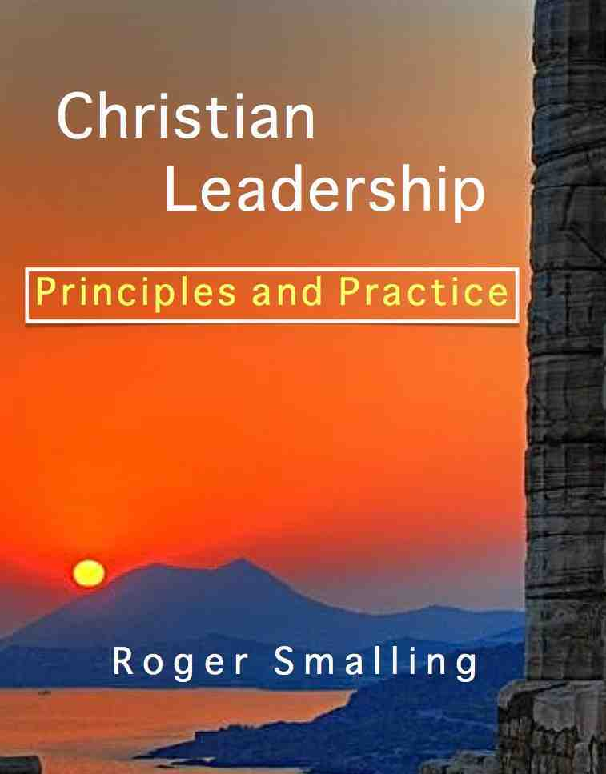

In the scenario described in Matthew Chapter Twenty, the mother of James and John approached Jesus asking that her sons sit beside him in his kingdom. This provided opportunity for Jesus to introduce three key attitudes in Christian leadership: Suffering, parity and service.

Suffering
The pressures of leadership are enormous. A leader must expect to suffer, often in secret, as part of his calling.

Parity
Ministers are equal in authority within the body of Christ. They relate to one another like knights at a round table rather than ranks in an army. Biblical government consists of ministers working together, with mutual respect as equals. Authoritarian hierarchies have no place in God’s kingdom. They are worldly in their conception and lead to the very things for which Jesus rebuked the two disciples in this passage.

Service
Leaders have a servant rather than ruler attitude. People are the focus of their ministry, not merely tools for their own ambitions.

What were James and John seeking and how did they go about it?
They sought status and honor through manipulation. They mentioned nothing of actual work to accomplish, just ranks. They assumed the kingdom of God would be set up just like any other government, with Jesus as supreme ruler, followed by a series of ranks.
We can imagine them plotting, “You know, Jesus can be a little tough on us sometimes. He’s really gentle with women, though. Let’s see if we can get mom to talk to Him. Maybe she can land a good position for us.”
This is politicking. Such manipulation typifies the world’s leadership. Jesus does not rebuke them for ambition because ambition is a good thing if it is for God’s glory. Instead, he warns against seeking one’s own honor.
Jesus makes it clear he is not in charge of promotions in the personnel department. The Father is. They were asking the wrong person.
From this, we see a hint of the first principle of Christian leadership in the New Testament: It is a gift from God.
Nevertheless, these sons of Zebedee had two laudable qualities, though seriously misdirected:

Ambition
This is a good characteristic if directed toward the glory of God rather than our own self-worth.

Confidence
There exists a self-confidence that is commendable if it is ultimately based on trust in God. Unfortunately, it was confidence in themselves rather than in God. “We are able.” They considered themselves eminently able. The garden of Gethsemane taught them otherwise. They abandoned Jesus and fled.
This brings up the first key attitude Jesus taught them.

First key attitude: Willingness to embrace suffering
You don’t know what you are asking,” Jesus said to them. “Can you drink the cup I am going to drink?” “We can,” they answered. Mt 20:22
The call to Christian leadership is a call to suffering. The suffering involved, especially in the western world, this usually takes the form of psychological pressure and stresses other believers neither bear nor understand.
People often have high expectations of a leader that he is able to meet. Some Christians may be looking more to a pastor than to Christ. When the pastor fails to meet their expectations, they may consider him incompetent.
Some under a pastor’s care may be insubmissive and will yield only when pressured into it. Sometimes the leader must hold the line on godly principles, risking misunderstanding and criticism.
Occasionally church leaders must apply biblical discipline when it may be unpopular to do so. When dealing with such, the leaders often cannot reveal the problem to the congregation. Members with incomplete knowledge of the case may draw wrong conclusions about the leaders’ decisions. They may imagine the leaders are too harsh or too lax in discipline. The leaders may find themselves suffering in silence. Yet, God has wisely arranged it so.
Titles and honors that accompany the office of leader are insufficient to compensate for the stress. Those who highly value titles or honors more than service, soon find themselves disillusioned.
Similarly, in his book, Brothers, We Are Not Professionals, John Piper attacks the attitude of professionalism in pastoral ministry that undermines the willingness to embrace suffering.
We pastors are being killed by the professionalizing of the pastoral ministry. The mentality of the professional is not...the mentality of the slave of Christ. Professionalism has nothing to do with the essence and heart of the Christian ministry... For there is no professional childlikeness (Matthew18:3); there is no professional tenderheartedness (Ephesians 4:32); there is no professional panting after God (Psalm 42:1).

Second key attitude: Parity
Jesus called them together and said, “You know that the rulers of the Gentiles lord it over them, and their high officials exercise authority over ` with you. Instead, whoever wants to become great among you must be your servant, 27 and whoever wants to be first must be your slave— Mt 20:25-27
On the mission field, I worked with a newly ordained national who happened to be a medical doctor. He had some rough edges to his personality, independent and opinionated. Over time we became great friends and worked well together. Let’s call him José.
Eventually, José moved to another city to work with a team. A missionary from that team called me and asked, “Roger, I’m having trouble getting along with José. I noticed you get along fine and work productively together. Can you give me some clues as to how to handle him?”
This was my answer: “Brother, in the first place, quit trying to handle him. Treat him as a colleague. Call him up once in a while and ask his advice. Ask him to help you. Think of him as your equal because after all, he has the same ordination as you. Do this and he will eat out of your hand.”
The missionary paused on the phone for about twenty seconds. “I don’t think I can do that,” he replied. “Then I cannot help you,” I concluded.
This missionary could not consider a national, even a medical doctor, his equal. He saw himself on the rung of a hierarchy with the nationals a lower rank. Treating José as an equal would have contradicted his entire view of leadership, inherited from his corporate business culture.
Ironically, I had used the term equal to avoid saying I thought José was the better man! It never occurred to me to think of him as inferior. The relationship between the two lasted less than a year before José went elsewhere.
A tip: If you treat a man as an equal, assuming he is wise, he will defer to you in areas he knows you are superior.
Authoritarianism and hierarchicalism support each other. It is hard to tell which is the driving force. Do authoritarian people create hierarchies? Or is it the reverse?
Authoritarianism is a byproduct of arrogance. Authoritarian people often suppose their superior office proves they are inherently superior as individuals. This is why they lord it over others. They assume they have a natural right to do so.
Complex hierarchies are inevitable in the world. Armies are hierarchies, with generals at the top, followed by colonels, majors, captains, sergeants, on down to privates. Likewise, corporations. The CEO is at the top, followed by vice presidents, department managers, on down to stock personnel in the basement.
Hierarchies are indeed necessary in such domains. Jesus is not teaching hierarchies are inherently wrong. He is simply saying not so with you.
In Greek the phrase, Not so with you, is literally, It shall not be so among you. Jesus was speaking in Aramaic, a dialect of Hebrew. In that language, future tenses are used as imperatives. Jesus was probably saying, “I categorically forbid you to put into office those with authoritarian temperaments and attitudes.”
This excludes some so-called “natural” leaders from Christian offices. Christian organizations often ignore this principle. Along comes a man with natural leadership traits. Sure, he is a bit arrogant. He likes to control. Maybe he’s a bit overbearing at times, but so what? He has leadership. So he attains to authority within the organization. Result: Wounded people. Good people lost, who refuse to be the brunt of his arrogance.
Just because a man has leadership ability, does not mean he should be a leader in a Christian organization. If he tends toward authoritarian and controlling attitudes, he is the last person to be qualified. Controllers must be controlled.
This may be what Jesus meant by, whoever wants to become great among you must be your servant. Some scholars have interpreted this phrase to mean, ‘servant leadership is the way to get promoted in the kingdom of God.’ This interpretation may be valid. Considering the context, however, it seems more likely a prohibition against appointing people with authoritarian attitudes.
The point: Neither natural leadership ability, experience in business or the military, nor psychological profiles are sufficient indications a man should be considered for Christian leadership. If he holds autocratic attitudes, thinks hierarchically or tends to use or abuse people, he is disqualified as a candidate, regardless of other attributes.

Third key attitude: Service
…just as the Son of Man did not come to be served, but to serve and to give his life a ransom for many. Mt 20:28
Christian leadership focuses more on helping others than commanding them. It is a life given to service.
Many who are attracted to honors, wind up as negligent leaders, more concerned about status than the welfare of their people. These do harm to themselves as well.
There is a time when a man lords it over others to his own hurt. Eccl 8:9
The goal of a Christian leader is to make his followers the best they can be. In fact, if he can train someone to replace him, that is the best leadership of all.
Servant leadership is essential in the kingdom of God because of the end product. In the business world, people are a resource to produce material goods. People give time and energy to produce products for public consumption. God’s kingdom uses material resources to produce sanctified people.
The world considers this a non-issue. After all, sanctification is difficult to define, something only God can measure. Yet, sanctified people is what the ministry is all about.
Occasionally businessmen say, “If I ran my business like you run your church, I would go bankrupt.” The answer might well be, “If I ran my church like you run your business, I would have no more sanctified people than you do in your business.”
The title of this lesson is, “The Christian Philosophy of Leadership,” not “A Christian Philosophy...” This is deliberate. Christ taught one philosophy of leadership. He did not say, “Try my suggestions and if you don’t like them, invent your own paradigm.”

Conclusion
Christian leadership involves attitudes different from worldly systems. Embracing the suffering, whether psychological or physical, helps a leader put his own motives into perspective. Serving others to help them reach their full potential and treating fellow ministers as equals is more than the mere duties of an office. It is a way of life.

From this lesson we learn:
- There exists only one philosophy of leadership in the Bible, the one taught by Christ.
- Embracing suffering and service, along with an attitude of parity toward one’s fellow ministers are essential attitudes of Christ’s philosophy of leadership.
- Ambition is good, as long as its focus is to see God glorified.
- Confidence is good as long as it is based on confidence in God.
- God the Father alone is in charge of promotions in his kingdom. Neither politicking nor influence are means for obtaining them.
- Jesus forbids his disciples to appoint to offices those with authoritarian attitudes.
- Neither leadership temperament, psychological profiles nor experience in worldly hierarchies qualify a person for leadership in God’s kingdom.

Smalling's articles and essays are available at www.smallings.com

Piper, John. Brothers, We Are Not Professionals. p.1-2

