How to Be Guided by God
by
Roger Smalling, D.Min
This article corresponds to the book
Personal Revival
available on Kindle
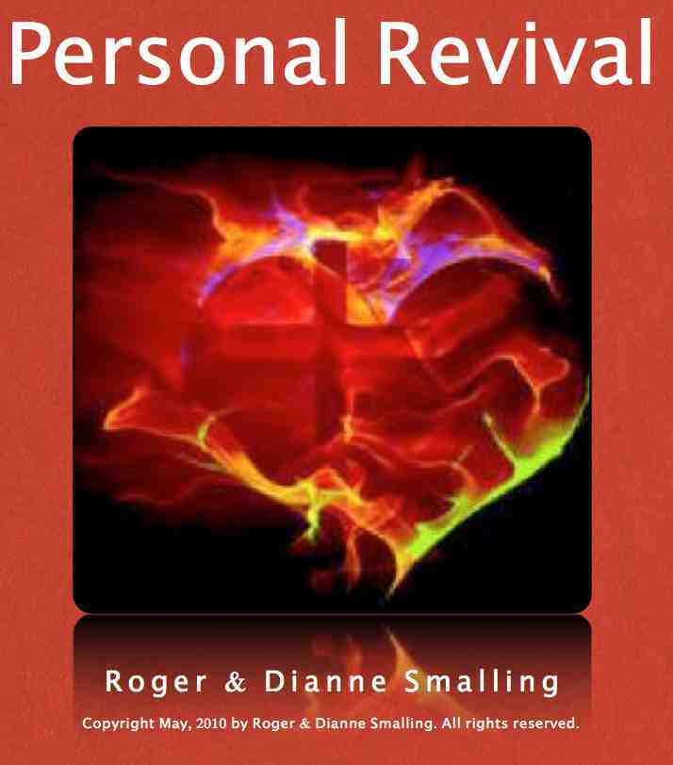

Years ago, Dianne and I found ourselves on the southern border of Texas, preparing to enter Mexico as missionaries. We didn’t have the faintest idea exactly where to minister in that vast country. So we spent a day in a Texas motel, seeking God’s direction. It was a typical missionary situation. We were on the way, but did not know exactly where to go. The Lord spoke to both of us through some biblical principles.
While we prayed, we felt peace that we should go to the next large city in Mexico, beyond the border towns. This meant Ciudad Victoria, about 200 miles south of Texas. Someone had given us the name of a missionary there we’d never met. The next day, off we went.
On the north side of Ciudad Victoria, we looked up the missionary. Over the next couple of hours, he shared how he desired to start another church in a section of town that had none, but an up-coming move to Guadalajara left him no time. He introduced us to the family that wanted a church started on their property. We unpacked our suitcases and our ministry in Mexico started there and then! God's personal word to us was fulfilled to the letter.
This sounds like we literally fell into God's will through a simple chain of events. Yet I vividly recall the feeling of uncertainty as we wrestled for guidance in that motel room.
Is it normal to find yourself puzzled over God's will from time to time? During a recent Bible study on divine guidance, a new Christian complained that God's will is sometimes difficult to discern. "Why doesn't he speak audibly and just say what he wants?” he asked. We shouldn’t feel something is wrong because God's will is temporarily obscure. Good reasons exist for this phenomenon.
The Lord sometimes speaks in striking ways. At times we have no doubt about guidance.
But finding God's will is frequently harder, as though he were deliberately hiding it. The Christian may feel like a detective hunting for clues. He digs into the Word, seeks counsel, and prays for guidance. He wishes God would speak louder. He might even develop feelings of inferiority, because he cannot hear God clearly. Eventually, clues seem to point in one direction so that he reaches an intelligent conclusion about what God wants.
Few things irritate me more than brash, boastful people who insinuate their level of faith brings them an accurate and almost instant discernment of God's will. I simply don't believe them. Both God's Word and the experience of Christians throughout history indicate that such boasting has roots in pride rather than genuine experience.
Divine Guidance is based on Godly Wisdom. Ephesians 5:17 clearly links wisdom with understanding the will of God.
…do not be foolish, but understand what the Lord’s will is.
Since no one attains perfect wisdom in this life, it follows that we all have plenty to learn. God graciously rescues us when we make honest mistakes. This reflects more on his ability to guide than on our ability to follow.
The element of mystery in discerning his will exists to provoke growth in wisdom and knowledge. When teaching about guidance, we spend more time on the aspects of guidance combined. Let's take a look at some of these characteristics from James 3:17,
But the wisdom that comes from heaven is first of all pure; then peace-loving, considerate, submissive, full of mercy and good fruit, impartial and sincere.
In this verse I focus on detecting the characteristics godly wisdom. We are not expected to acquire great wisdom before being able to follow the Lord accurately. Such a prerequisite would produce fear and bondage. Christians have a natural sense of unworthiness, due to an awakened conscience. Satan tries to pervert that virtue into an inferiority complex. To understand the characteristics of Divine Wisdom let’s read James 3:17. And here's what we find…

First pure
When we have to make an important decision we can always compare it with this passage. If the characteristics match, the decision is probably right. If any are missing, especially the first one, purity, it is a satanic trap. If it passes this first test, we can then ask God for confirmation via other signs.

Satan can counterfeit any aspect of this list in James 3:27 except purity. Any element of shady dealing, duplicity, or little white lies, is clear proof that the whole affair is diabolical in origin.
During our ministry in Ecuador, a couple in the States offered us a car. It seemed to be a genuine answer to prayer. Though certain importation restrictions intervened, a little white lie to the Ecuadorian government could resolve everything. After all, we reasoned, the whim of the local official seems to be the legal practice here, so what difference does it make? We're doing Kingdom business. It's really no concern of theirs. (We can always rationalize a decision if we want something badly enough!)
We had no peace. We talked to the Lord about it and he pointed out James 3:17. The word pure finalized our decision. We rejected the couple's kind offer. Later God provided honorably and honestly through another means.

Peace-loving
Which does it create: Unity or dissension? I must qualify this because righteousness will always cause dissension where people are in sin. Purity is more important than peace. Notice that pure was mentioned before peace in this verse.
Jesus said, ...I came not to send peace, but a sword. Mat.10:34 In that context, he was talking about the conflict between good an evil that would center on Him.
Paul said in Rom 12:18,
If it is possible, as far as it depends on you, live at peace with everyone.
Some Christians desire peace to the point of being willing to sacrifice righteousness, or shade the truth. Some permit sin and false doctrine to go on rather than reprove it. Whenever we sacrifice purity for the sake of peace, we lose both.
Truth-loving Christians will sense peace if the decision is from the Lord. A group of godly peers can often be to us what a safety rope is to a mountain climber.
For lack of guidance a nation falls, but many advisers make victory sure. Prov 11:14

Considerate
The word in the original Greek, used only this one time in the New Testament, carries the idea of being reasonable. The Amplified correctly renders it, "willing to yield to reason". Have you ever met the self-assured zealot? Remaining open-minded can protect us from mistakes. But when the mind closes to new evidence, it often becomes closed to God.

Full of mercy and good fruits
What is the end result of the decision to be made? What is the ultimate fruit of it? Who will it help, and how? These questions can shed a lot of light on important decisions.

Submissive
Two young boys, new Christians, began to receive what they thought were leadings and messages from God. Along with this came the instruction that they should keep it from their pastor because he wouldn't understand. This went on for a while until some of the messages started getting a little weird.
Eventually, one of the boys became suspicious. He wondered if it made sense for the Spirit of God to reveal things to them he hid from their spiritual leader. After going to his pastor, he found out of course, that they had been hearing from the wrong spirit.
The apostle James goes to a lot of trouble to clarify the difference between worldly and Divine Wisdom. This can be summarized by two words: Pride vs. humility. The pride inferred is the most subtle and dangerous kind: spiritual pride. It is deceives the victim to consider himself wise, though he usually harbors envy and selfish ambition.
The most humble man, for the least reason, I have ever personally met was the late Dr. Francis Schaeffer. I visited his ministry in Switzerland several times while serving as a missionary in Geneva. He had four doctorates. Yet the first thing I noticed about him was his quiet, self-effacing manner. But when he spoke, it was what I call quiet thunder.
Years later, as missionaries to Ecuador, we visited the jungle. There the characteristics of Divine Wisdom as the key to guidance were visually illustrated for me. The Lord used the native huts to show me the relationship between wisdom’s characteristics and the various other signs that he uses to guide us.
I noticed the Indians spent as much time on the foundation as the rest of their dwelling altogether. Only after a solid foundation was in place, generally a wooden platform raised well above the ground, would they put up the corner posts. This foundation can represent the characteristics of Divine Wisdom while the posts portray the specific signs by which God guides us. Everything depends on the foundation for its stability.
One last caution before we go on to the various signs the Lord may give: Believers hungry for wisdom sometimes dedicate themselves to a study of the Book of Proverbs. But a Christian can no more attain wisdom by reading Proverbs than he can get righteousness by reading the Law of Moses. Why? Because, ... one greater than Solomon is here. Mt 12:42
The wisdom of Christ is as superior Solomon's as Christ's righteousness is to that of the Law. Solomon's wisdom is acquired. Christ’s is intrinsic. Solomon learned through experience and observation. Christ is God's wisdom incarnate.
All of God's Word is to be studied and honored, but not every portion has the same relevance to the New Testament believer. God's Word is a progressive revelation, moving from the lesser wisdom to the greater. While Proverbs encourages a love and hunger for wisdom, Jesus is the fulfillment of it. Proverbs can help us to a degree, but we need more.
…become for us wisdom from God — that is, our righteousness, holiness and redemption. I Cor 1:30
As we seek God's will, we must remember an essential principle: Never rely on once sign only. While traveling from Los Angeles to Houston, I noticed the highway department had wisely placed signs at regular intervals to reassure the driver. The long and lonely stretches of desert can cause him to doubt if he is really on the right road. One signpost isn’t enough for the whole trip.
Ask God for confirmation. Don't fear that this will displease Him. Uncertainty is no sin if motivated by a sincere desire to honor God.
The great apostle Paul prayed three times for the Lord to remove his thorn in the flesh. Obviously he passed through a time when he was unsure of God's will regarding this problem.
People sometimes decry Gideon's lack of faith when he asked for confirmation via the fleeces. However, if an angel told me to attack 100,000 armed men, I would want some confirmation too! I see no scriptural evidence that God gets angry if we aren't sure of his will. Sometimes he allows a questioning period to provoke us to seek Him.
Now let's look at some important sign-posts by which he confirms direction:

SIGN-POST 1: Personal leading from scripture
As you read the Bible during your daily quiet time, be attentive to the Holy Spirit within you. He will often point out verses as clues about his will.
We can approach God's Word this way as long as we keep in mind a couple of key points: First, we must be careful to take the principle embodied in the text as our guide, and not read into the text meanings not intended by the writer. Second, we should not attempt to judge others based on what God is telling us.
It should be superfluous to say that God never leads a person contrary to the principles in his Word. Yet we continue to meet people who hold to doctrines or leadings totally contrary to Scripture, based on a dream, inner impression or a prophecy from someone they respect. Some even claim special "revelation knowledge" superior to the written Word of God. Well-grounded believers know the difference between personal leadings from God through the Word, and the evaluation of doctrine through sound principles of Biblical research.

SIGN-POST 2: Inner peace
Let the peace of Christ rule in your hearts… Colossians 3:15
When standing at a crossroads between two decisions, we can use the peace of God in our hearts to help determine God's will. In choosing one of the roads at random, your peace may disappear as you start off on it. This indicates it's the wrong one. Turn around and go back down the other one. In your peace returns, it's probably the right choice.

SIGN-POST 3: Godly counsel
Obey your leaders and submit to their authority. They keep watch over you as men who must give an account. Hebrews 13:17
Men of God, seasoned by years of experience, will usually be able to detect a satanic trap. Better still, they can sort out subtle mixture of truth and error, a favorite enemy tactic to confuse Christians. Every minister knows the grief when a believer falls into a trap that could have been avoided if only they had pursued counsel. God often uses the minister as a safety-check before one attempts to launch into something dubious.
Yet, as with all truths, this one also must be kept in balance. The clause "them that have the rule over you" is a misleading translation of one single Greek word, HEGEMON, which simply means "guides". The true Christian leader is neither dictatorial nor imposing.
A mountain guide knows the path to take, the cliffs to avoid, and how to use the ropes. But he doesn't walk behind his followers with a whip and force his bidding.
Some immature ministers view their role as control and manipulation of others. Others assume they have a gift of knowing God's will for those around them. These make poor counselors.
A few years ago, the shepherding movement was popular in the U.S. It involved a near blind submission to the authorities of the church. The goal was to deter innate tendencies toward rebellion and independence, and promote growth in Christ. This has just enough truth in it to be dangerous. Yes, attitudes of independence characterize many Christians. It is indeed difficult for pastors to deal with this. Yet the Shepherding Movement backfired.
Why? It inevitably produced spiritual immaturity. People weren't taught how to hear from God for themselves. It resulted in Christians with Biblical doctrine but a cult-type mentality. Though this movement has largely disappeared, a similar pattern of thinking still exists among some individuals in the ministry. The best pastoral counsel is that which helps the believer hear from God for himself.

SIGNPOST 4: Open doors
See, I have placed before you an open door that no one can shut. Rev 3:8
…a great door for effective work has opened to me, and there are many who oppose me. I Cor 16:9
Notice Paul mentions adversaries. Sometimes we assume adversity is a sign the leading is wrong. But the reverse is often true. We are in a conflict and can expect opposition when God wants us to do something for Him.
Do the above points guarantee 100% accuracy in knowing God's will? Certainly not. We never stop learning in this life. He uses Divine Guidance as a means to teach wisdom and understanding. Furthermore, God wants the element of faith to be central to our walk with Him. How could faith be involved if all risks were removed from guidance?
Insecure Christians tend to insist on certainty before launching into faith on any decision. This, of course, is self-contradictory. If we were always certain, how could faith be involved? Genuine faith steps out, believing that God is leading, trusting him to correct any mistakes.
Those who insist on a perfect system of Divine Guidance in this life are involved in a futile search. And those who claim to have found one are self-deceived. Our faith must ultimately rest in God's ability to direct us rather than the principles themselves, even though God uses these principles to guide us.
Smalling's articles and essays are available at www.smallings.com

