Creative Thinking
by
Roger Smalling, D.Min
This article corresponds to the book
Christian Leadership
available in Kindle.
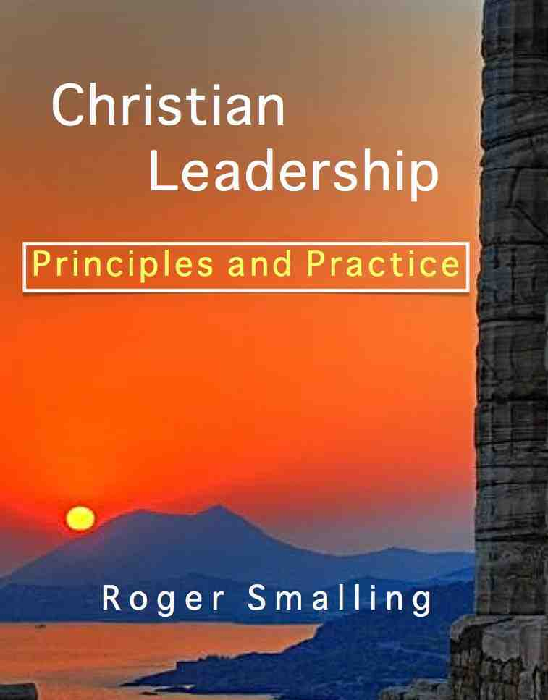
At a missions conference in the United States, the Sunday school teachers wanted all of the children to understand what a missionary does.
A couple of the teachers, however, objected. They felt the five and six year olds were too young to grasp the concept of missions.
The teachers conferred over the problem. One teacher had a shower curtain with a map of the world printed on it. During the conference, they took the curtain to the classes along with cans of shaving cream. They put shaving cream on the part of the map representing the USA, along with a few other countries that send out missionaries.
The teachers said the cream represented the message about Jesus. They explained to the kids that those were the countries where the gospel is preached. Then they asked the kids why there was no shaving cream on other countries. They explained something about the people in certain countries and that they did not have the gospel. So somebody must take the gospel to them. How?
They had the kids take off their shoes, step into the piles of cream, pick up some on their feet and walk it over to the countries in which there was none.
Toward the end of the conference, the pastor asked the five year olds, What is a missionary? The kids responded, “A missionary takes the message of Jesus to places where people don’t have it.”
Those teachers solved a problem some originally assumed impossible. They did it with creative thinking.
One of the key characteristics distinguishing genuine leaders from mere managers is creative thinking. It explains why some leaders seem content to maintain the status quo.

Definitions and elements
We can define creative thinking as the ability to invent original ideas for accomplishing goals.
The source of creative thinking is our imagination. This is a faculty of mind given which God expects us to use. Guidance often comes through the application of our own mental faculties.

Why are we poor at creative thinking?

Laziness
Thinking is hard work. Creative thinking is hardest of all. Just ask a novelist. Most will tell you they only write three or four hours a day because it is too exhausting.

Wrong theology about guidance
Christians sometimes have wrong concepts about the mind. They wait for God to give revelation, while God waits for them to use the faculties He gave them. Result: Nobody moves and nothing gets accomplished.

Repression of creative faculties
A college professor put a small dot on the blackboard. Then he asked the class what it was. The students all agreed is was nothing but a dot of chalk on the blackboard. The teacher replied, “I did the same exercise yesterday with a group of children. One thought it was an insect egg or perhaps a bird’s eye. Another thought it was the head of a bald man seen from an airplane.”
Why the difference? In the years between kindergarten and adulthood people discard their imagination. Why? They learn to be specific about things, giving the right answers and being realistic.
Absorbing facts is not the same as exercising the mind. In some countries, the education system is based on rote memorization. Students write down verbatim what the teacher says, then copy it neatly into a notebook at home. This is supposed to be education. It is not education. It is brainwashing.

Fear of failure or ridicule
Nobody wants to make a fool of himself. The temptation toward this becomes stronger as we advance in leadership. We think, “If my new idea fails, we’ll look like fools and people will lose confidence in us.”

Negative thinking
What is the difference between a leader who gets things done and those who only manage the work of others? The former ignores the reasons why it can’t be done and does it anyway.
Great entrepreneurs rarely ask, “Is this going to work?” Instead, they are challenged by, “How can we make it work?”

Comfort zone
We confine ourselves to comfortable limitations. It seems so much easier to do the familiar. Sometimes it is good to stretch out of our comfort zone, and attempt that in which we may not feel gifted.

Group brainstorming
At a meeting in a paint company, technicians were seeking new ideas for removing paint. One man humorously suggested mixing dynamite with the paint. That way, years later they could toss a match at the paint on the wall and blow it off.
Once the laughter died down, the group took this bizarre idea and came up with a surprising solution: Mix a chemical with the paint that could react later with the paint if pasted over to dissolve it. This is how paint remover was invented.
Is there any reason a group of Christians cannot excel in brainstorming? A stroke of genius is sometimes modified stupidity. Knowing this may help us break through inhibitions.

Summary
Creative thinking entails using our imagination for inventing original ideas to solve problems. Barriers exist in this process. Effective leaders overcome them.

From this article we learn:
- God wants us to indulge in creative thinking because he gave us the faculty of imagination to do it.
- Numerous barriers to creative thinking exist. We need to be aware of them.
- Brainstorming is a good way to practice our creative faculties.
Smalling's articles and essays are available at www.smallings.com

Isaac Asimov, the great science fiction novelist in a radio interview, said most people could write a story if they would concentrate on it hard enough. He claimed talent was secondary. A disposition to hard work was the secret. I took this as a challenge because I felt he was underestimating his own talent. So over a weekend I concentrated as hard as I could on a story idea. The result: A 6000 word story on my web site I titled, Phobia. It is an inferior example of science fiction but that is beside the point. Azimov was right.
Illustration taken from A Whack on the Side of the Head by Roger Von Oech, Ph.D

