VISION IN LEADERSHIP
The essentials
by
Roger L. Smalling, D.Min
This article corresponds to the book
Christian Leadership
available in Kindle.
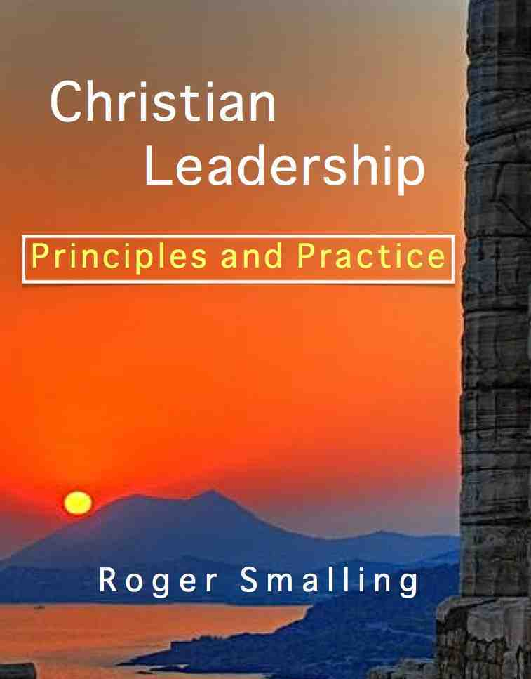

What is vision?
How do we get it? How do we implement it?
To answer these questions, let’s look at three leadership styles often found in Christian circles: Pioneers, managers and janitors. This list is not exhaustive. Some individuals may be a mixture.
Pioneers have a vision for something new. This person is the trailblazer, taking risks to go where no one has gone before or do something in a new place. He has enthusiasm, drive and creativity. He is impervious to criticism and impatient with those who play it safer.
Though pioneers are great for getting things going, they usually make poor administrators. They generally lack patience for the minutia of administration. They tend to lose interest in projects once initiated, preferring to go on to something else.
Managers follow in the footsteps of a pioneer, carrying forward the vision the pioneer has established. He puts order into vision. Though he also owns the vision, he may be dissatisfied with the implementation. He sees more clearly the means to accomplish the goal.
Janitors are conservative types who desire to institutionalize the vision to maintain results as they are. In a church setting, these people tend to lack vision for anything new. We use the term janitor because their primary concern is that everything is kept clean and safe. If the congregation is morally clean, with sound doctrine and committed to the status quo, they are content.
They spend time dealing with disciplinary cases, discontent people or those with deep problems. Leadership development is not their focus. They perceive themselves as spiritual leaders because they have success dealing with these types of problems. It is questionable if they may be called leaders at all.
They tend to resist new projects because they themselves have no compelling goals. Their focus is keeping everyone happy. If spiritual janitors are placed in primary leadership, it is highly unlikely the church will grow numerically.

Ingredients of vision
Vision is an attainable dream. It involves two aspects:
- A dream
- A workable plan
This means a goal of great value, difficult to attain, requiring long-term investment of time and personnel.
Both must exist to qualify as vision. A plan without a dream lacks the momentum to attract the necessary leaders to make it work. A dream without a plan is merely visionary and never gets off the ground.
The Protestant Reformation was the result of the vision of several men like Luther, Calvin and Knox. It was a goal of immense value, costing many lives over three generations. The religious freedom and prosperity many countries enjoy today is the direct result of that vision.
In the political domain, the Latin American revolution under Simon Bolivar was the result of a vision. Bolivar dreamed of the liberation of an entire continent. The vision was costly and required a lifetime investment of resources. A continent was worth it.
A vision need not be as ambitious as these examples. Every successful church or organization was started by a person with the vision to see it happen.

A vision without a plan is merely visionary
Listening to a visionary may be entertaining but so are novels. Eloquence does not equal vision.
Some articulate, intelligent people can be eloquent about what needs doing. They may be more adept at analyzing the deficiencies of others than creating workable plans. Though they appear knowledgeable and confident, one never quite grasps exactly what they are saying. It is like catching smoke. Politicians are often this way. These are visionaries at best and leaders, not at all . . . wind-bags to be ignored.

A dream and a plan is not quite enough
Some may have a dream and a plan and still not be leaders. A third element must be present; the personal drive and commitment to implement it. Without this, all they will only be trying to persuade others to do the work.
A dream and a plan without drive is like a sports car with a driver who won't turn on the key.

Elements of a sensible vision
Simplicity. The vision should take only a few seconds to explain. Otherwise, it is too complex. People need to understand the vision in order to support it. Any promotional literature should project the vision in its first line or two.
Slogans and acronyms help people grasp the idea.
Difficult, but not impossible. If it were easy someone would have already done it. If the goal is attainable and desirable, but has not been done, it is because either nobody believes it is possible or no one has the drive to attempt it.
To accomplish a vision, it takes a person who can distinguish between impossible and difficult. The ability to take what others see as impossible and evolve a plan for doing it, is the difference between a Christian worker and a Christian leader.

Characteristics of a godly vision

It must advance the kingdom of God, not your own self-esteem
How does your vision advance the Kingdom of God and produce holy people? Remember, God's goal is to create a holy people for His Kingdom and glorify His name this way. Anything we do must fit into this goal or our idea did not come from God. Some have built their own empires as monuments to themselves in the name of God's Kingdom.
Others have a strong psychological need to affirm their own self worth. Beware of motives.

It must be based on a personal call from God
Just because it is a good idea does not necessarily mean it is God's call for us to accomplish it. David had a great idea for building a temple to honor God. Nathan the prophet informed him that God was pleased with the idea, but it was Solomon who was called do it.

Summary
Although the Bible teaches only one philosophy of Christian leadership, leadership styles may differ, depending on temperaments and circumstances. Some are pioneers, others managers or maintenance people.
A leader is partly characterized by having the initial vision. A vision is an attainable and valuable dream that comes from God.

From this article we learn:
- Some leaders are pioneers, others are managers and others maintenance people.
- A vision is an attainable dream of lasting impact, difficult to accomplish and requiring great resource investment.
- A vision must be accompanied with a plan or it is simply visionary, leading nowhere.
- A vision must be simple enough for people to understand and get on board.
- The vision comes normally through a personal walk with God like any other calling.
- A genuine vision must advance God's Kingdom for His glory, not merely our own personal satisfaction.
Smalling's articles and essays are available at www.smallings.com

