WHAT IS SANCTIFICATION?
What is sanctification, and how does it differ from justification? Understanding the difference is essential for assurance of salvation
and a balanced view of the Christian life.


Many Christians are confused about the difference between justification and sanctification. The failure to distinguish between the two is behind both Catholic and Arminian errors.
It also contributes to insecurity in some believers. It also contributes to insecurity in some believers. They may base their security of salvation on their degree of sanctification rather than on their justification, which is absolute.

What is justification?
"Justification" means "declared righteous.” It does not mean made righteous. The meaning of the Greek word "DIKAIAO" entails the following principles:
- God requires that the absolute righteousness of the Law be fulfilled in all believers.
- Nobody can meet that requirement. Romans 3:11-19
- Christ is our substitute under the Law, fulfilling in our place the righteousness that the law requires. Galatians and Romans clarify this. Romans 8:4
- Through faith, Christ’s righteousness is attributed to us. Romans 3:2
- All those who are justified will be glorified. God accepts no accusations against His justified people regarding their eternal destiny. Romans 8:30-34

Why justification is permanent
No doctrine of de-justification exists in the Bible. God will never declare those justified by Him as non-justified. The sin problem was settled for God’s justified people. Paul considers it absurd to think any of the elect would be condemned. Romans 8:33
Justification is not a process. It happens once. The basis is the attributed righteousness of Christ, not the hit-or-miss works of the believer. The way is through faith in Christ. It is His righteousness and therefore cannot change.

What is sanctification?
Sanctification, on the other hand, is a process. It refers to our growth in holiness. The idea of process is included in the Greek word HAGIASMOS. A compelling example is Hebrews 10:14.
“For by one offering he has perfected forever those that are being sanctified.” (NKJV)

Sanctification as a process
This verse embodies an intriguing interplay of time sequences. First, he says that by one offering of Jesus he has already perfected some people. Not will be perfect, but has perfected. The second part is in the present continuous tense and is described as being sanctified.

Legal standing vs daily experience
The difference is between our legal standing with God and our daily experience. When Christ died on the cross, His sacrifice was the guarantee of our ultimate perfection. Therefore, God attributed to our account, in a legal sense, the perfect righteousness of Christ. This made us acceptable to Him, despite our present imperfections.
God accepts us as perfect because the righteousness is that of Christ, not our own. When Jesus died on the cross, His last words were, “It is finished.” (John 19:30) This means the debt of sin is paid in full for all believers. Nothing can be added to this account. It is already full.
Yet God is a realist. He knows we are weak and fail to live according to the righteousness Christ purchased for us. Life for the believer, then, is the process of learning to live according to that righteousness attributed to us through Christ. Thus, the second part of the verse...those who are being sanctified. This indicates the progressive nature of sanctification.
Distinguishing the difference between justification and sanctification is crucial. Those who believe they can lose their salvation base their acceptance with God on their own level of sanctification, rather than God’s decree of justification. The ground on which they stand is their own obedience, not Christ’s. That ground is shaky.

Progressive sanctification
Sanctification is progressive, yet easily confused with justification. Nevertheless the two have an important aspect in common… inevitability. God promises to complete our sanctification. He doesn’t say how, only that he will do it.
“May God himself, the God of peace, sanctify you through and through. May your whole spirit, soul and body be kept blameless at the coming of our Lord Jesus Christ. The one who calls you is faithful and he will do it.” 1 Thessalonians 5:23-24

Preservation versus perseverance
When such Christians declare they have security of salvation, they are really making a calculation based on their determination to persevere rather than on God’s ability to preserve them. That ground is more than shaky. It is dangerous.
Imputation of the righteousness of Christ is the central issue. Once a believer sees salvation is more than just forgiveness of sins, his whole perspective of acceptance with God changes. The entire books of Galatians and Romans make sense like never before.
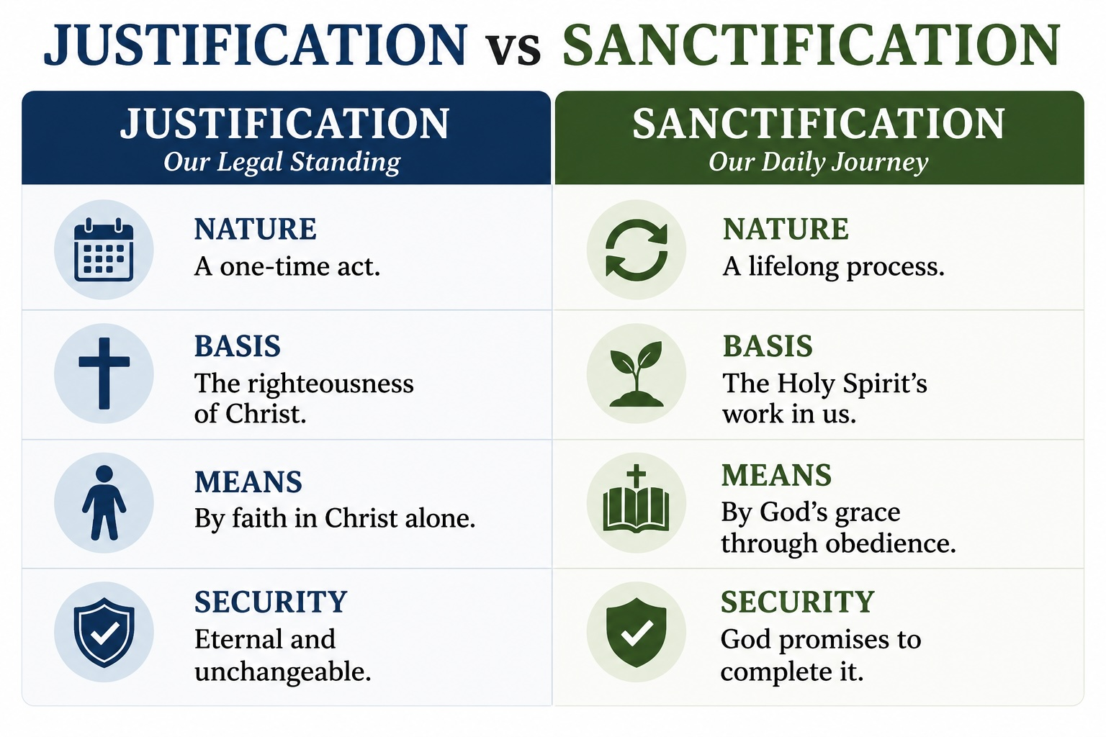

Common errors about sanctification

Perfectionism and the second blessing
Some groups mistakenly think sanctification is a one-time spiritual experience after conversion, in which a believer becomes perfect in this life. Though I have met some who hold this doctrine, I have yet to meet any who are perfect.
This kind of error has two causes. Scripture sometimes describes sanctification as an inevitable consequence of God’s work in the believer. Some assume they must have obtained it now. This assumption is a logic error.

Antinomianism and grace
Another error is based on antinomianism, the belief that the law is meaningless for Christians because Paul taught we are not under the law but under grace. When Paul said this, he meant the law is not a means of justification. The Ten Commandments still apply as moral guidelines. We cannot obtain righteousness from them, but we sin if we break them.
Since antinomians reject God’s moral law, they create other standards to replace it, usually based on their own strengths. Then they declare themselves sanctified. Whatever standard they invent, it will always be less than what God requires in His eternal moral law. Some groups even claim they don't “sin” anymore. They just make “mistakes.”

Why the distinction matters
The Bible does not teach any second blessing experience after salvation that can be identified as a complete sanctification in this life. Any such teaching is wrong. It confuses justification with sanctification, ignores the continuance of God’s eternal moral law, leads to spiritual pride, and holds an insufficient view of the corruptibility of human nature.
No theological subject can be divorced from the entire Bible. Each doctrine is connected with every other. It is impossible to provide a complete explanation of any one doctrine without reference to numerous others. If we view sanctification in the light of justification, the definition becomes clear.

###
You may use this article for ministry purposes.
Free books, essays and study guides
Related articles:
Joyfully Justified: A study guide on justification
Can a Christian Lose Salvation?
How to Grow in Faith
If you liked this article, you may enjoy our book,
Joyfully Justified
